Project Name: CI/CD Deployment for Springboot Application.

GitHub Link:

<https://github.com/tamasjit/SpringJenkinDocker>

## Output:

### Jenkins Dashboard:

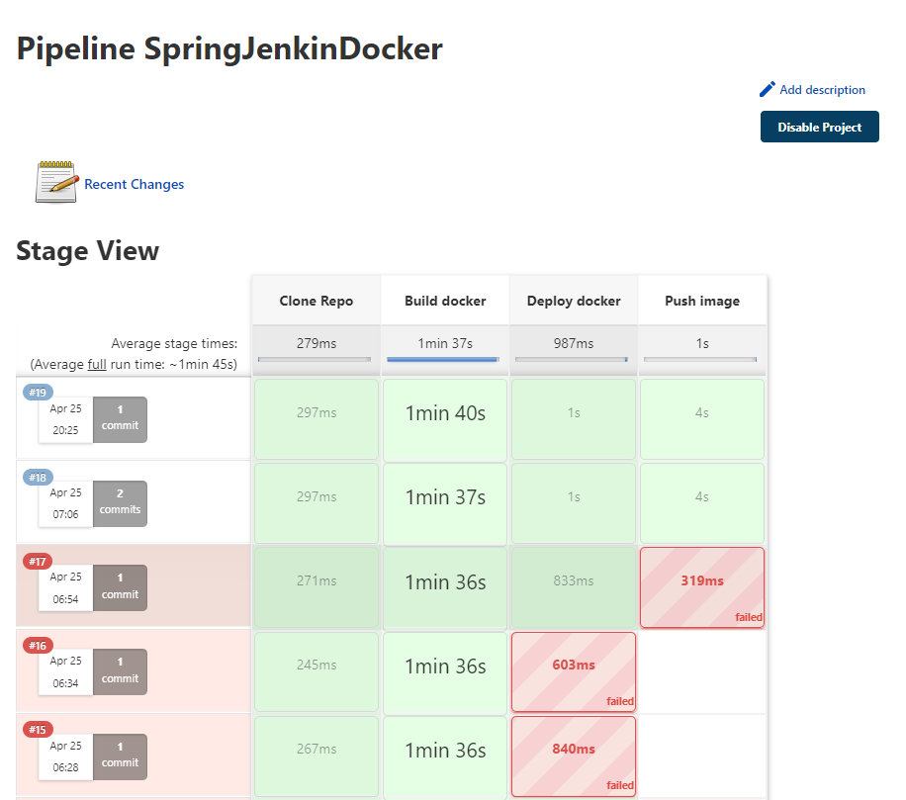

### Jenkins Console:

### User Data Editing:

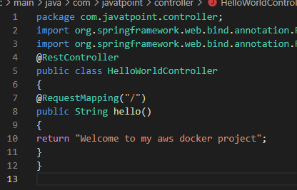

### Contact Form:

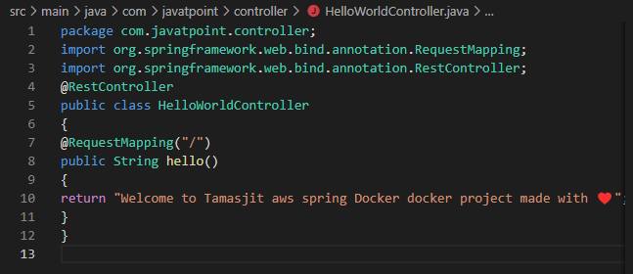

### Commit from GitHub Desktop Application:

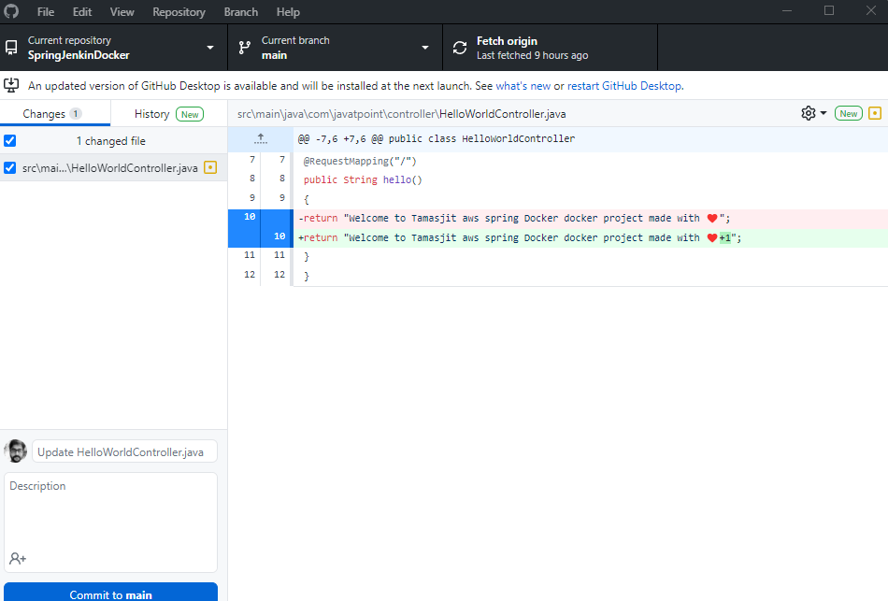

### Occurring changes after successful commit Automatically:

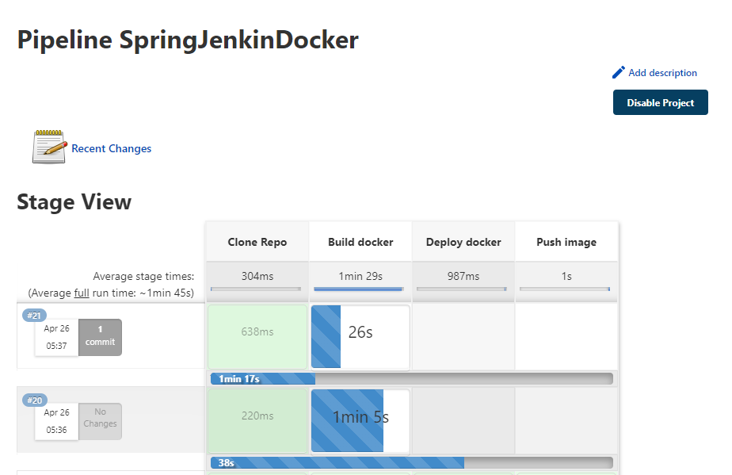

### Output on 8081 Port:

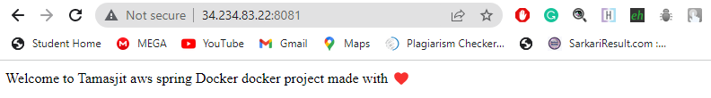

### Blue Ocean View:

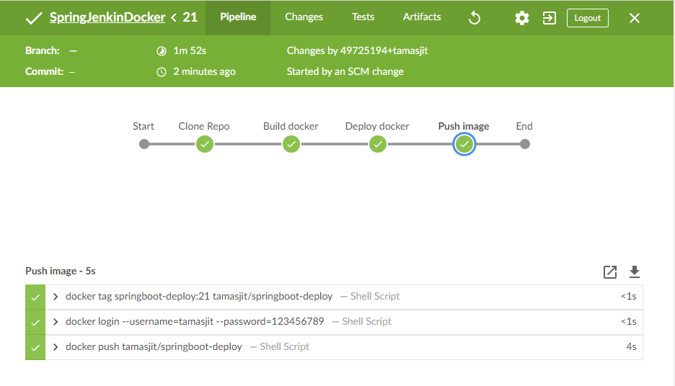

### Output on 8081 Port after build from new commit:

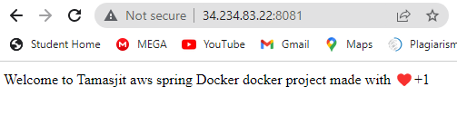

### Docker Repo:

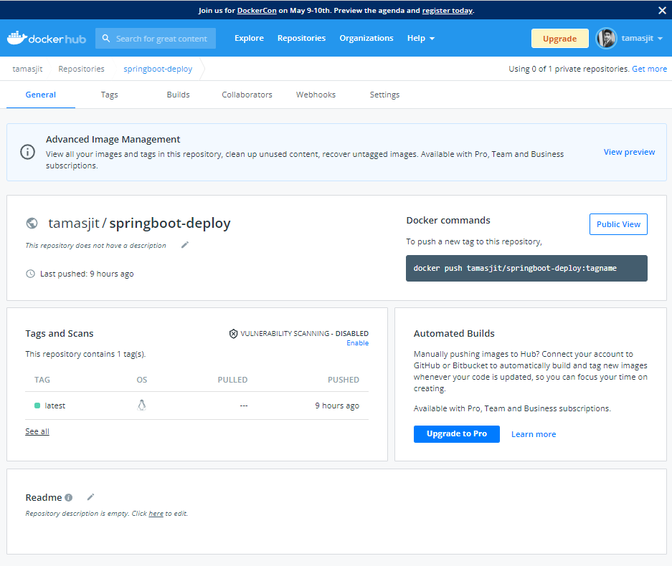

### Output from final docker container on another AWS EC2:

